Advantages of using AI in Government and Public Sector- A case study on AI-powered Disaster response in Japan

Alicia Gonzalez Cruz

Prof. Anna Devarakonda

ITAI 2372

As the use of Artificial Intelligence increases in social media, it has also started to be implemented in many other sectors, such as government and public services. Governments worldwide are increasingly adopting AI technologies to improve public service delivery, enhance decision-making, and address complex societal challenges. In the **government** and **public sector**, AI is used in diverse ways to drive efficiency, transparency, and innovation. It’s being used in many sectors such as public health, transportation, fraud detection, and social services. Despite its enormous potential, the integration of AI into government functions raises important ethical, regulatory, and technical challenges. These include concerns about data privacy, algorithmic bias, transparency, and the impact of AI decisions on citizens' rights. However, when properly implemented, AI can enhance the efficiency and effectiveness of government operations, creating a more responsive, accessible, and informed public sector.

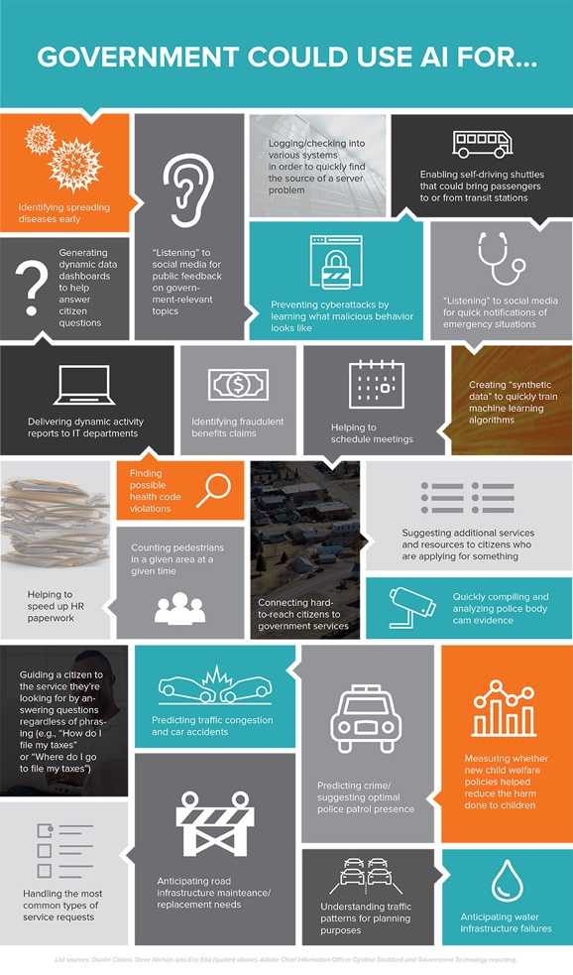

In this case study, we will discuss how AI is becoming a handy tool for governments when dealing with natural disasters. Instead of relying only on traditional methods, AI helps predict things like earthquakes, floods, or typhoons by analyzing tons of data super quickly. This means emergency teams can get alerts faster and have more time to prepare or warn the public. During a disaster, AI also helps determine where resources, like rescue teams or supplies, should go first, based on where the most damage is happening or where people need the most help. It even supports communication by powering apps or chatbots that give people real-time updates. Overall, AI helps make disaster response faster, smarter, and more organized, which can save lives and reduce chaos when things go wrong.

I have chosen to mainly address an analysis of Japan’s AI in disaster response because it’s a system that has brought many advantages to the public sector of Japan. Not only that, but it has also shown the Japanese government that implementing AI in the country can be beneficial. Japan is considered one of the biggest countries in the world and a disaster-prone place. It faces “frequent heavy rainfall, earthquakes, tsunamis, and volcanic activities.” These disasters can cause massive destruction, loss of life, and disruption to communities. Traditional disaster management methods often struggle with the speed and scale of emergencies, especially when rapid decision-making and resource deployment are critical. Japan decided that by implementing AI technologies, the government would be able to analyze past data, which would help predict future patterns that can prepare or warn the public. The AI system can also send faster alerts to the people and deploy emergency teams to the affected areas. Overall, AI helps make disaster response faster, smarter, and more organized, which can save lives and reduce chaos when things go wrong.

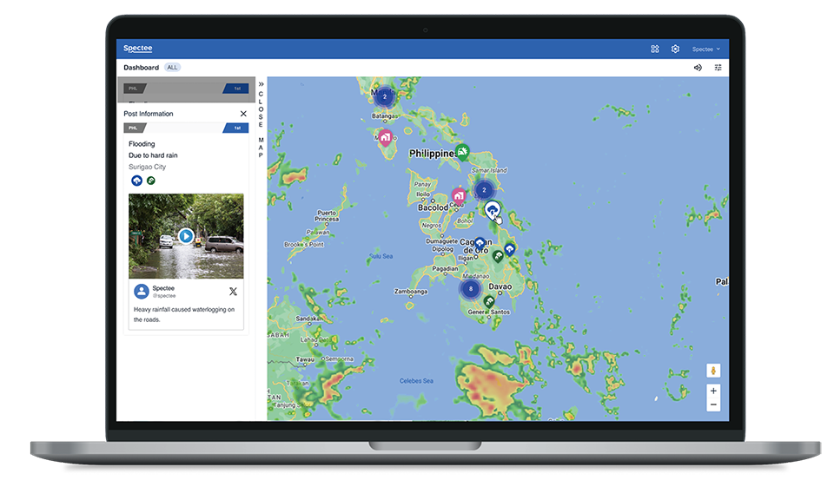

Some of the specific tools implemented in the several AI-powered systems that Japan is using include predictive analytics, machine learning models, AI-powered surveillance, drones, natural language processing, social media monitoring, and smart city infrastructure. These tools help address the challenges in a more modern way. Most of the outcomes achieved by these AI systems bring a lot of benefits, for example, improved accuracy and precision of forecasts. As well as AI chatbots and platforms help keep people informed and calm during emergencies, reducing confusion and panic, which is very beneficial for the government as it makes protocols run smoothly. And as the main benefit that the Japanese government has seen since implementing this system is the cost saving, because the response process reduces the strain on human resources and lowers the cost of recovery operations. Not only that, it also saves money by preventing disasters in the infrastructure, which can cause expensive repairs or the loss of innocent lives.

However, like every other AI system, it also has its challenges and limitations. Japan does a good job of getting its citizens to understand and feel comfortable with AI, but some believe AI-powered tools are not reliable. There is a limitation in overdependence on technology; relying on an AI system is risky, as power outages and technical difficulties may happen during a disaster. Given the problem regarding privacy and surveillance concerns, many may argue that using AI as a monitoring device may raise ethical issues around surveillance and consent. That’s where one of the main challenges emerges: the digital divide- not everyone has access to devices or the internet needed to benefit from the AI system, especially the rural and elderly populations. Which can be very harmful in the end, as it creates a bigger problem, such as ethical and societal harm. There are also other limitations, such as data quality, bias, infrastructure, and false alarms. In the end, implementing an AI system can be both beneficial but also challenging to work with.

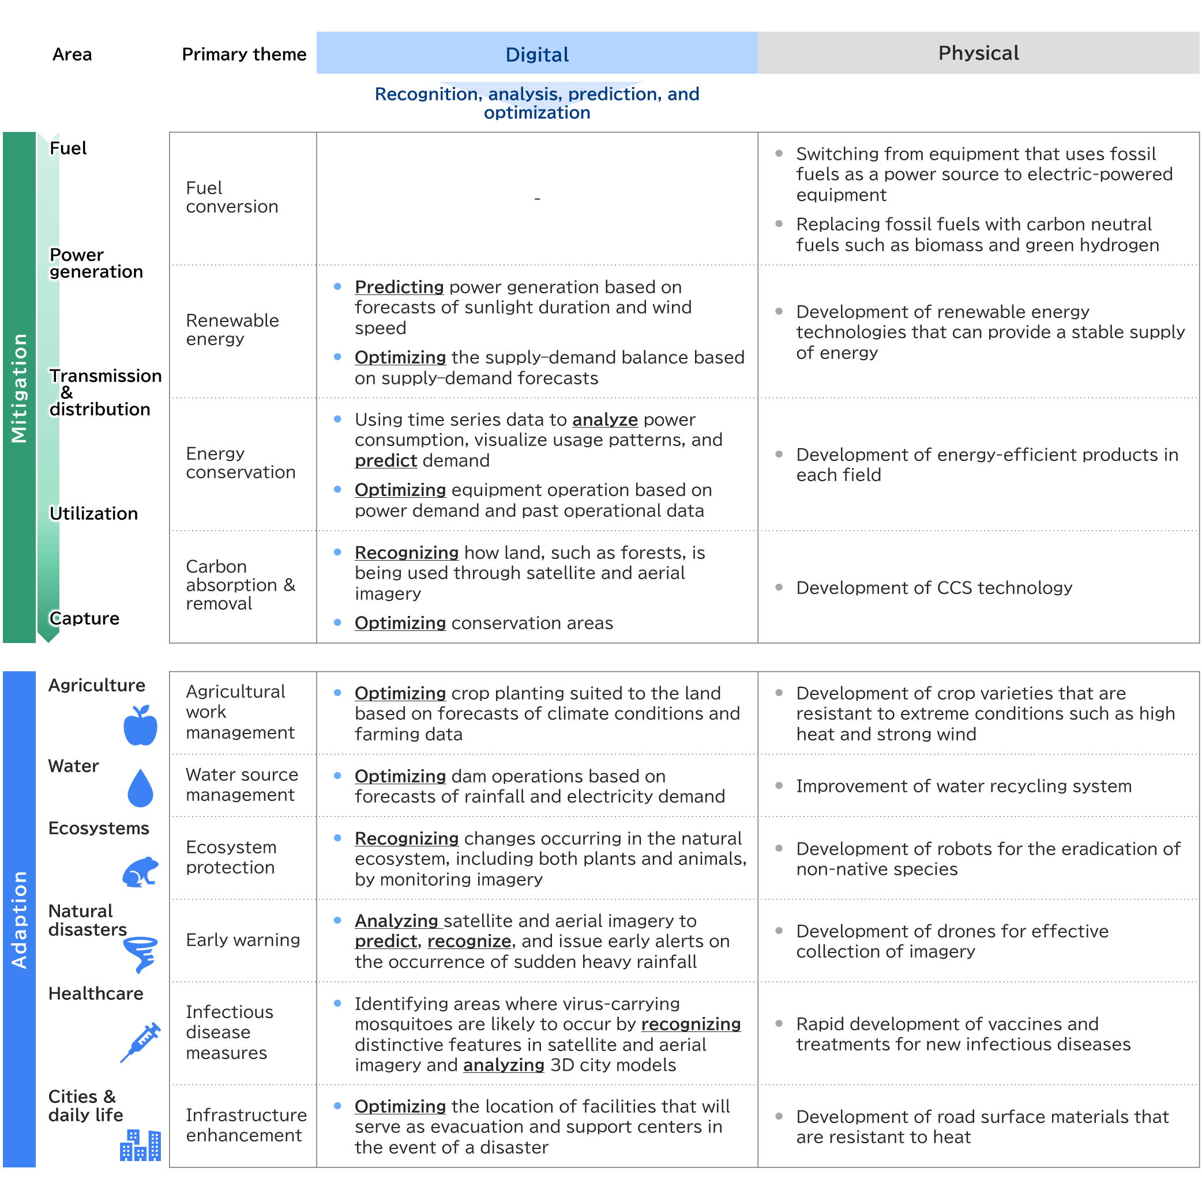

An innovative proposal that I believe will take Japan's AI weather system a step further will be suggesting a smarter system that can react and adjust in real time during emergencies. This proposal will specifically meet the country’s need for rapid, flexible, and accurate disaster management. This AI-driven dynamic response system will build upon Japan's current weather system and create a more integrated, adaptive network. The main key point of this proposal is the integration of real-time data sources, meaning it will collect social media scraping using NLP, as well as collect live input from sensors across cities. The second key point will be smart evacuation & resources coordination, AI will analyze data and recalculate optimal evacuation routes in real-time, reassign emergency personnel, and distribute supplies in real-time in a rapid manner. The last key point will be to localize public alerts and support, everyone will have access to alerts and notifications through a specific app, in multiple languages, as well as employ AI chatbots to serve as an advisor for those who have questions and guide them to safety.

The AI-driven dynamic response system proposal will not only expand the AI system Japan already has in place, but it will also lead to positive outcomes. For example, it will allow Japan's emergency services to respond in real time and reduce delays. It will also update evacuation plans instantly to help save more lives. In addition, it will make better use of limited resources and help build stronger community trust. Even though this system could be helpful, there are still a few challenges to think about. One big issue is data privacy. Since the system would be monitoring things like social media and public cameras, people might worry about their information being misused or feeling like they’re always being watched. Another problem is that the system would need to work across a lot of different government agencies, and not every place might have the right technology or fast internet, especially in rural areas. There’s also the chance that the AI could mess up, like misreading a social media post or getting bad data from a sensor, which could cause wrong decisions if no one is double-checking it. Plus, not everyone has access to smartphones or tech tools, especially older people or folks in remote areas, which could make it harder for them to get important updates during a disaster. However, it is a proposal that will bring a lot of change to Japan's public community.

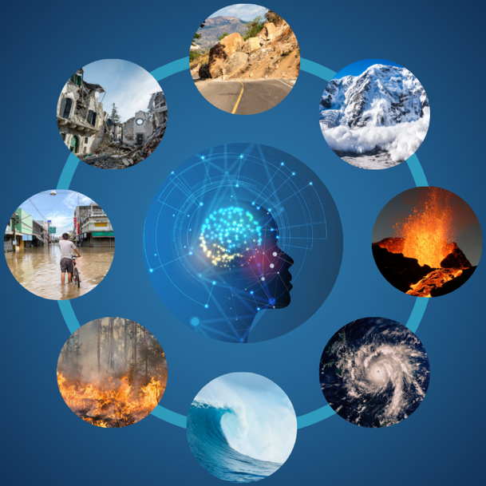

Overall, Japan’s use of AI in disaster response shows just how powerful AI can be in government and public services. By using AI to predict disasters, send out warnings faster, and manage resources better, they’ve been able to save lives and reduce the impact of emergencies. The proposal for an even more dynamic, real-time AI system could push those benefits even further by making responses even quicker and smarter. Even though there are some challenges, like data privacy concerns and making sure everyone has access to the technology, the potential advantages are huge. AI can make government services more efficient, more responsive, and better prepared for the unexpected, especially in places like Japan, where natural disasters are a constant risk. With the right balance between innovation and responsibility, AI can be a major game changer for public safety and community trust.

Citations

*AI-Driven Climate Change Solutions and Their Future Japanese technology plays pivotal role post-COP29 | Research Articles | Mitsubishi Research Institute, Inc.* (2025). Mitsubishi Research Institute, Inc. https://www.mri.co.jp/en/knowledge/article/20250310.html

Hagerty, C. (2024, January 4). *Japan spent decades making itself earthquake resilient. Here’s how.* National Geographic. https://www.nationalgeographic.com/environment/article/japan-earthquakes-resilient-architecture-disaster-preparedness

IBM. (2024, December 20). *AI in government*. Ibm.com. https://www.ibm.com/think/topics/ai-in-government

Jijo Malayil. (2024, August 27). *Japan to use AI-powered drones for crime prevention in disaster zones*. Interesting Engineering. https://interestingengineering.com/innovation/japan-ai-powered-drones-monitor-disaster-zones-criminals

Ministry of Foreign Affairs of Japan. (2019). *Disasters and Disaster Prevention in Japan*. Mofa.go.jp. https://www.mofa.go.jp/policy/disaster/21st/2.html

Oguchi, T. (2024). *NATURAL DISASTERS IN JAPAN DUE TO INTENSIFIED STORMS AND HUMAN IMPACTS ON LAND*. Confex.com; GSA. https://gsa.confex.com/gsa/2024AM/webprogram/Paper403898.html

to. (2024). *Tokyo implements AI-driven system to accelerate disaster response*. Aa.com.tr. https://www.aa.com.tr/en/asia-pacific/tokyo-implements-ai-driven-system-to-accelerate-disaster-response/3302329

Veeksha Dechamma. (2025, March 24). *The Role Technologies in Enhancing Japan’s Disaster Resilience - Jumpstart Magazine*. Jumpstart Magazine. https://www.jumpstartmag.com/the-role-of-ai-and-technology-in-enhancing-japans-disaster-resilience/